DESSERTS
MALAYSIAN STYLED PINEAPPLE FRITTERS 8.50
Fried pineapple with sweetened milk & cheese
Add ice cream + 2

MALAYSIAN STYLED BANANA FRITTERS 8.50
Fried banana served with sweetened milk & cheese

RED BEAN SESAME BALLS 10
Sesame balls filled with red sweet beans

ICE CREAM SUNDAY 10
Chocolate or strawberry sauce with honey
Crumble & Chocolate

MALAYSIAN DRINKS
MALAY TEH TARIK (hot or cold) – 1 pot 10.50

COCONUT JUICE – 1 Jug 10.50

CREAMY PINK SODA – 1 Jug 10.50

MILO DINASOUR – 1 Mug 5.90

SPIDER LEMONADE – 1 mug 5.90

WELCOME

TO THE GRAND

CENTRAL HOTEL MIDLAND

Welcome to the Grand Central Hotel Midland.

Hani & Karl have been the new owners since 2019. Our aim is to provide freshly

prepared meals for you to enjoy. Cooking all the meals fresh may take us a little

longer but we think its worth it.

Our Malay meals are traditional “based”, we have designed our flavors to suit the

taste buds of our local customers.

None of the meals are chili hot unless you would like to challenge your taste buds!

Menu items may contain or come in contact with wheat, eggs, nuts & milk, for more

Information, please ask our friendly staff.

gfo – Gluten free option – please notify staff

vo – Vegan option – please notify our staff

STARTERS

SPRING ROLLS (x3 large) 8

Served with sweet chili sauce

VEGETARIAN CURRY PUFFS 14.50

BEEF CURRY PUFFS 17

GCH Nanas traditional spicy curry puff served with dill mayo

SATAY CHICKEN 16.50

SATAY BEEF 18

Traditional Malay street flavored skewers grilled & served with house made

satay sauce, cucumber, cubed rice & onions on the side

GRILLED WINGS (x 10) 18.50

Grilled chicken wings with your choice of flavor

Malay coconut

Honey and caramelized date

Hot chilly

HOT CHIPS GRAZING PLATTER

FOR 2 30 FOR 4 55

Sweet potato, beer batter, thin chips & wedges with a 4 tasty house

Made sauces

BEER BATTER CHIPS 10

SWEET POTATO CHIPS 12

GLUTEN FREE CHIPS 12

WEDGES 12

KL chili paste & sweet chili sauce

rendang, rice, Roti cheese, chicken satay,
KL chili paste & sweet chili sauce

selection Of 4 different sauces
BEER BATTER CHIPS 10
SWEET POTATO CHIPS 12
GLUTEN FREE CHIPS 12
WEDGES 12

KL PLATTER for 2 58
Samosas, curry puffs, spring rolls, chicken rendang, beef rendang, rice, Roti cheese, chicken satay,
KL chili paste & sweet chili sauce

selection Of 4 different sauces
BEER BATTER CHIPS 10
SWEET POTATO CHIPS 12
GLUTEN FREE CHIPS 12
WEDGES 12

KL PLATTER for 2 58
Samosas, curry puffs, spring rolls, chicken rendang, beef rendang, rice, Roti cheese, chicken satay,
KL chili paste & sweet chili sauce

BREADS

GARLIC BREAD 6.50

CHEESY GARLIC BREAD 9

BRUCHETTA 9
Mixed salad, olives, feta & balsamic dressing

MURTABAK ROTI
Chefs traditional recipe, soft & crispy flat bread, filled with
Egg, onion & a choice of fillings, served with KL chili paste &
Curry sauce on the side

PLAIN ROTI 13 (no filling)
CHEESE ROTI 17
EGG ROTI 17
CHICKEN ROTI 19.50
BEEF ROTI 21.50
VEGGIE ROTI 18 (contains curry potato & onions only)

MALAY RICE MALAY NOODLES

NASI LEMAK 20.50 CHAR KUEY TEOW
Malay coconut pandan rice. Served sambal fried crispy Malay fried flat noodles cooked with beans spouts,
Anchovies, toasted peanuts and cucumber cabbage, carrots, spring onions & egg. Served with
Add 2 chicken satay sticks + 7.50 cucumber & tomato slices on the side
BEEF 23
NASI GORENG 19.50 CHICKEN 20.50
Malay fried rice cooked with veggies, Served with lightly SEAFOOD 24 (Prawn, squid & fish cake)
battered chicken pieces, fried anchovies, fried egg,
cucumber & tomato slices on the side KL chili sauce
Add 2 chicken satay sticks + 7.50 MEE GORENG

SILKY NASI GORENG Malay yellow noodles cooked in chefs’ dark sauce,
Malay fried rice cooked with veggies, surrounded with with sprouts, cabbage & carrots. Served with cucumber
silky egg sauce. Topped with soft fried egg & tomato on the side
CHICKEN 22 CHICKEN 20.50
BEEF 23.50 BEEF 23
VEGE 20 SEAFOOD 24
Add 2 chicken satay sticks + 7.50 VEGGIE 18

SIZZLING RENDANG LAKSA
Deiced beef or chicken, braised in coconut milk, served Malay laksa noodles created for the local taste buds
with rice, cucumber & tomato slices on the side Please ask wait staff if you would like it spicy HOT!
CHICKEN 26.50 CHICKEN 22.50
BEEF 28 BEEF 23
VEGE 20 SEAFOOD 24
VEGE 19

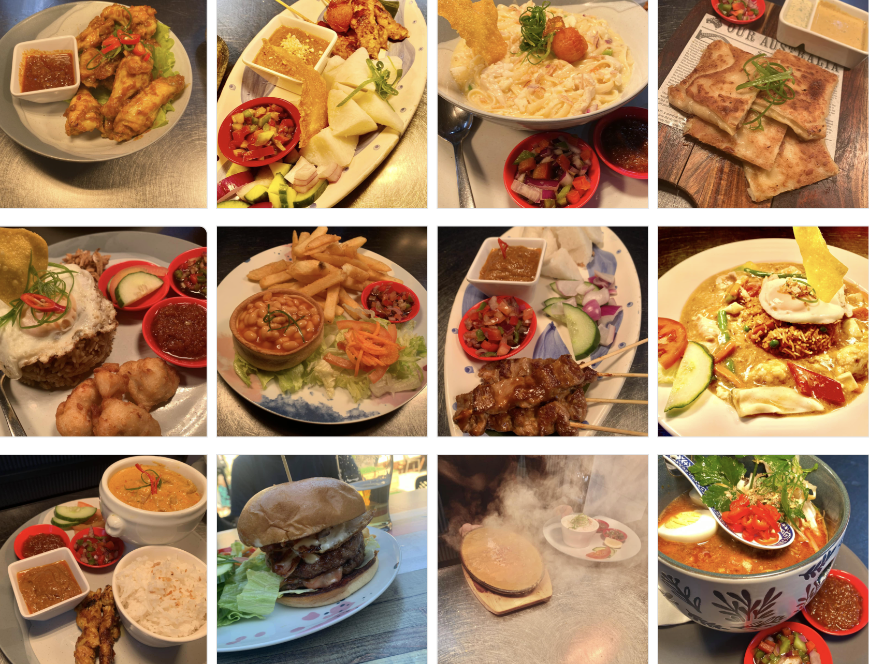

PUB MAINS  CHILLI MUSSELS  Small 17 – Large 23  Steamed in our house made Napoli sauce  Mild or Hot Option  LIME & PEPPER CHICKEN 24.50  Grilled Chicken breast marinated in lime & pepper,  Served garlic sauce, chips & salad  & side salad  STEAK SANDWICH 26  180g scotch fillet fresh bread, caramelized onion, swiss cheese, lettuce & tomato  Served with beer battered chips & side salad  BUILD YOUR OWN BURGER 16.50  Choose your Bun – Soft white, gluten free, vegan  Choose your Pattie – Beef, veggie or vegan  Choose your Sauce – Tomato, chili, mayo, tartare, ranch  Choose your Burger salad – Yes or No  Choose your Fillings + 3ea – Egg, bacon, jalapenos, pickles, caramelized onion  Cheese included  Served with beer battered chips & side salad  Overview of Programs 1  Getting Started 2  What to Include 2  Focus on What You Do Best 2  Don’t Forget the Mission 3  Make It Your Own 4  Customize in Almost No Time 4  Make It Picture Perfect 4  Our Products and Services 5 |  |  | PUB MAINS  PARMI SELECTION  Juicy crumbed chicken schnitzel, topped with Napoli  sauce, cheese & your choice of topping.  Served with beer battered chips & salad  TRADITIONAL PARMI 25  SATAY PARMI 27  SPANISH PARMI 27.50  RUMP  Cooked to your liking served with beer battered chips  Choose a sauce – pepper, mushroom, gravy, red wine or garlic  Rump 250g 28.50  Rump 300g 35.50  Add creamy garlic prawns (surf and turf) + 6  Mash & veg (no chips) + 2  FISH & CHIPS 26.50  Beer battered New Zealand hake fish fillets served with  Beer battered chips & salad  Grilled fish + 1.50  Mash & veg (no chips) + 2  CHICKEN CREAMY GARLIC PASTA 23  Linguine no1 pasta cooked in creamy garlic sauce, chicken, tomatoes & capsicum. Garnished in feta cheese & fried shallots  SCOTTISH PIE 18.50  Traditional pork pie served with beans chips & salad

